Python assignment - File Demo
Pranav Dhekane [2601048] [A]

Write a program to read a file and count how many vowels are present in its content.
with open("file.txt", "r") as f:
line = f.read()

count = 0
s = {"a", "e", "i", "o", "u"}

for i in line.lower():
if i in s:
count += 1

print(f"Number of vowels = {count}")

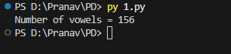

Read all lines from a file into a list. Print the total number of lines and display the 2nd and 4th line.
with open("file.txt", "r") as f:
lines = f.readlines()

print("Total number of lines = ", len(lines))

if len(lines) >= 4:
print("The 2nd line is: ", lines[1])
print("The 4th line is: ", lines[3])
else:
print("The file has less than 4 lines.")

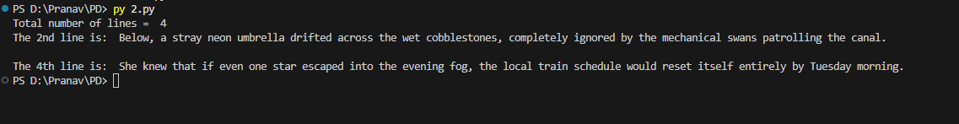

Take a sentence from the user, split it into words, and store them in a list. Print the longest word.
line = input("Enter a sentence: ")
words = line.split(" ")

maxlen = 0
maxWord = ""

for i in words:
if maxlen < len(i):
maxlen = len(i)
maxWord = i

print(f"Longest word = {maxWord} with length = {maxlen}")

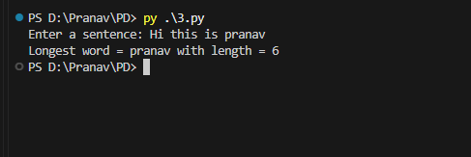

Read a file, split its content into words, and store them in a list.Print the total number of words.Print all unique words.
with open("file.txt", "r") as f:
content = f.read()

words = content.split()

print("Total number of words = ", len(words))

unique_words = set(words)
print("Total number of unique words = ", len(unique_words))

